Project Development – Delivery plan sprint-4

| Date | 17-Nov-2022 |
| --- | --- |
| Team ID | PNT2022TMID33886 |
| Batch | B8-2A4E |
| Project Name | Project - IoT based Safety Gadget for Child Safety Monitoring Notification |

**Creating a location tracker in the MIT app and to track the child's location and update it to the Parent.**

**Create App in MIT App inventor:**

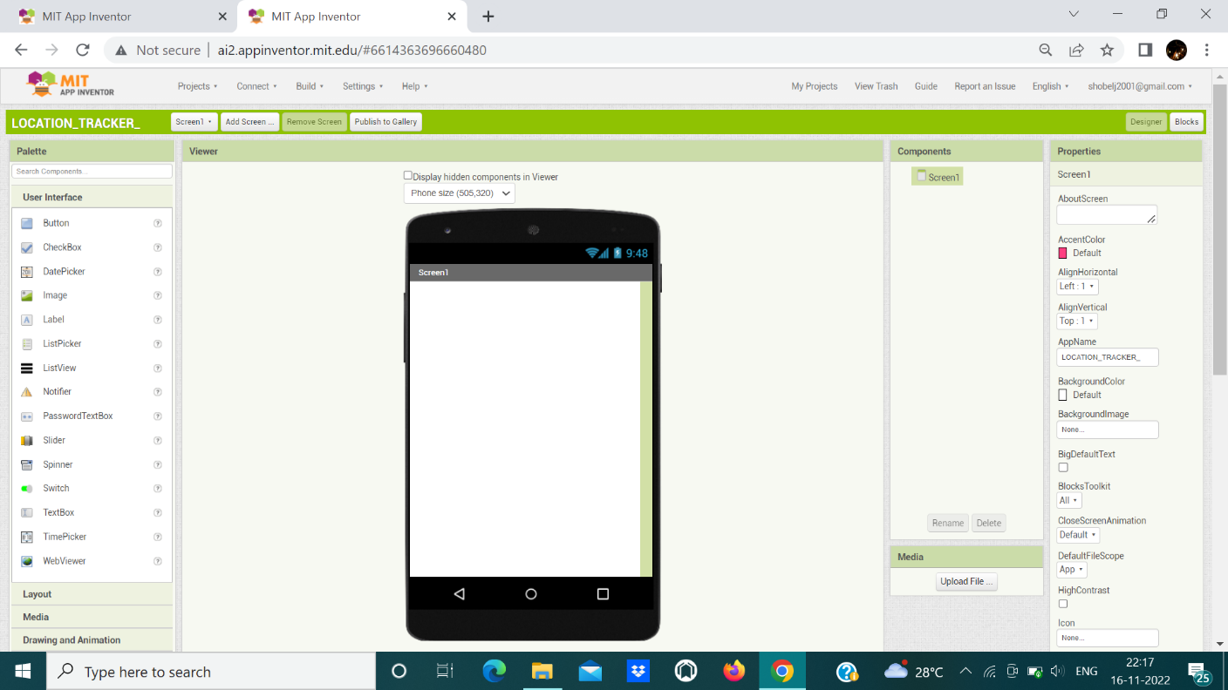

**Block Configuration:** 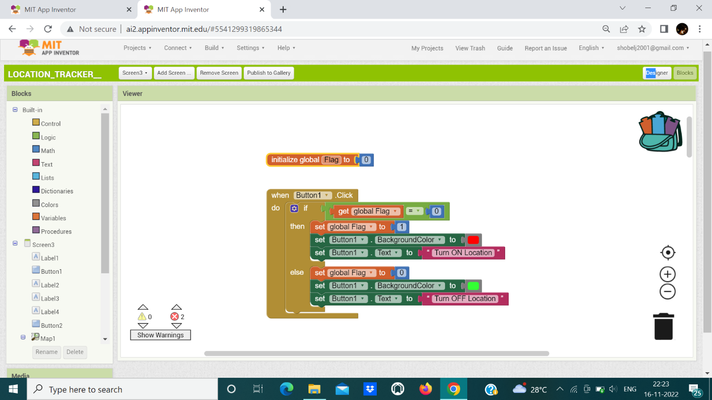

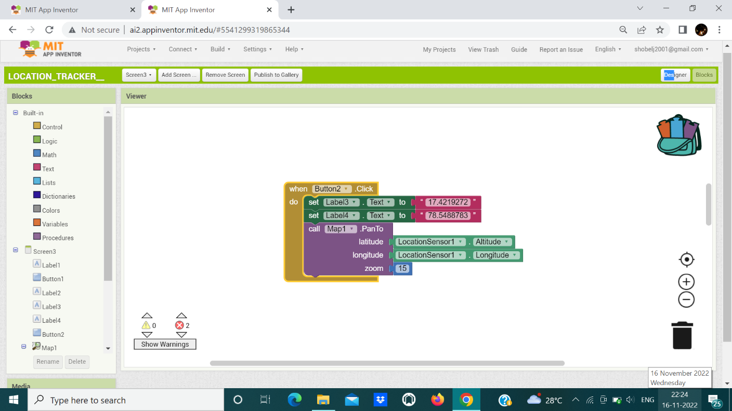

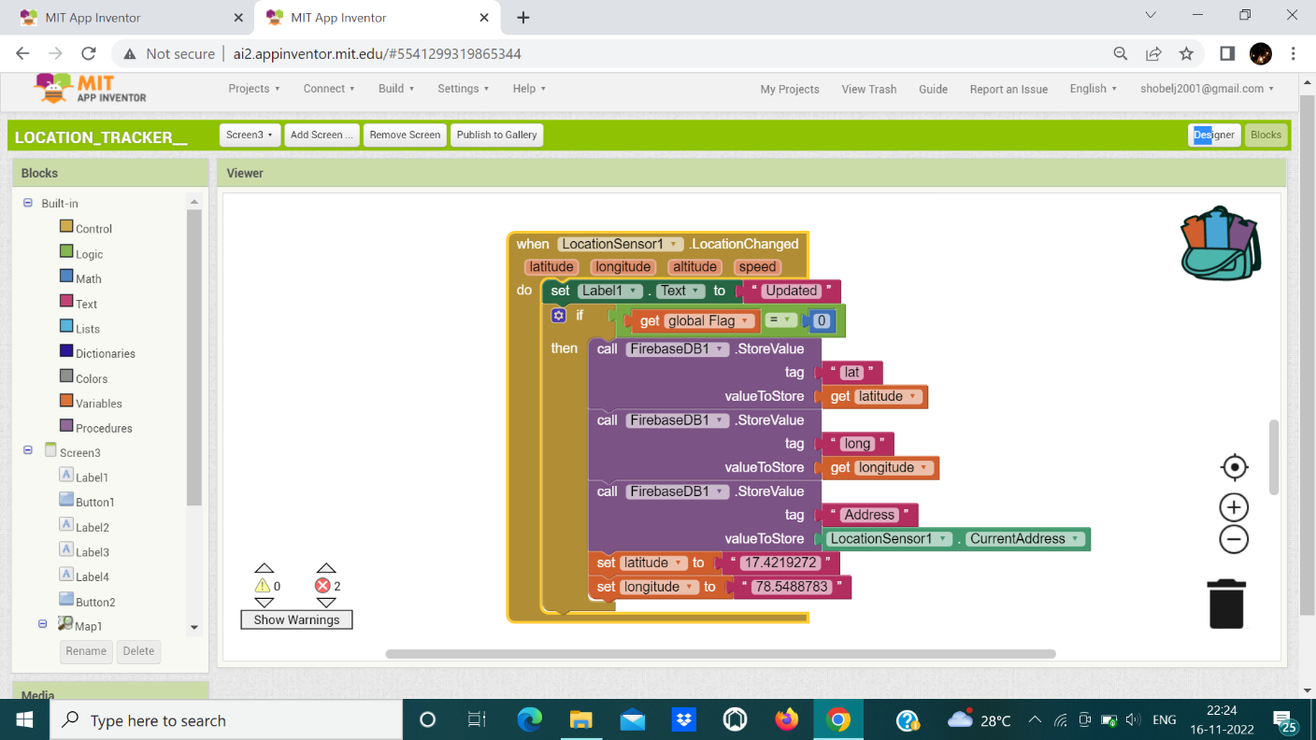

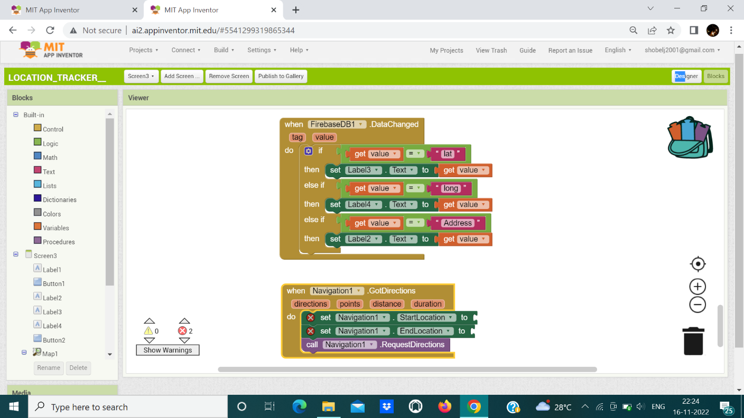

**Output (MIT App inventor):**

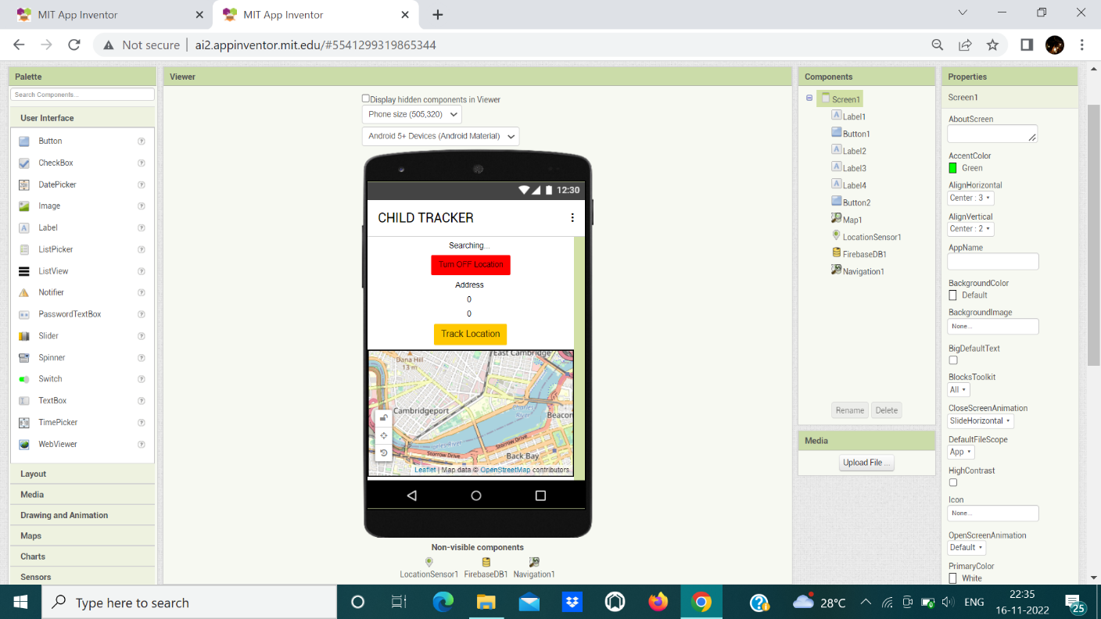

**Location Status:**

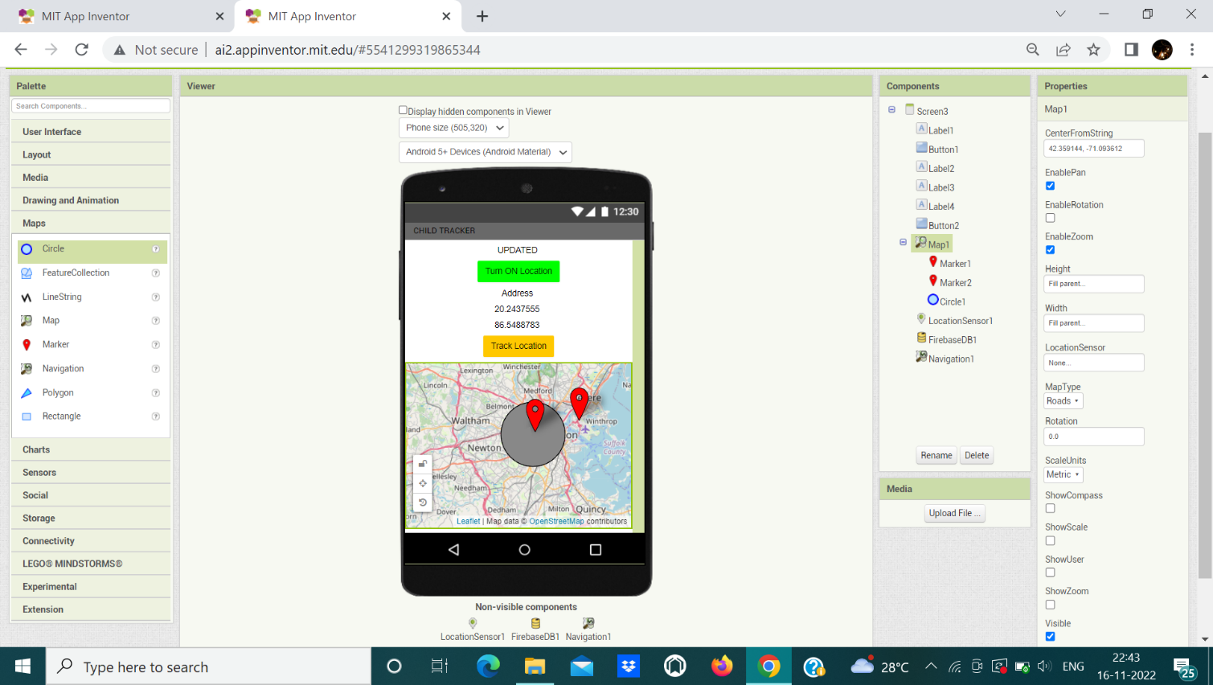

**Thus the location of children was tracked successfully.**